Put English Title Here
First Author’s name¹, Co-Author’s name², and Corresponding Author¹
¹Dept. of Mechanical Engineering, Town/City, Seoul 12791, Korea
²Dept. of Automotive Engineering, Your College, Town/City, MA 02139, U.S.A.
(2 line spacing)

Keywords: Put keywords here, and keywords should be written 5 or 6 words.
* Corresponding author, E-mail: Type the corresponding author’s email address here

Put abstract here. Put abstract here. Put abstract here. Put abstract here. Put abstract here. Put abstract here. Put abstract here. Put abstract here. Put abstract here. Put abstract here. Put abstract here. Put abstract here. Put abstract here. Put abstract here. Put abstract here.

Abstracts must be typed in good quality in this form with wide margins using MS-Word.
The language of the paper is English and should be written 1 or 2 pages.
Authors should submit an electronic file including a PDF file(2MB) of the abstract system at the APAC22 website(www.APAC22.org)
This abstract shall not exceed two pages and the keywords were written 5 or 6 words.

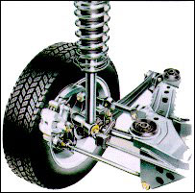
Photo. 1 Type here
* Reference
Referencing sources in the abstract and final paper shall be done with sequential numerical references, between square brackets.
Examples of citing references are given in the references section, for books [1], journal articles [2] and websites [3].

